# HTML and CSS

## EXERCISE 3: BASIC RESPONSIVE LAYOUT

Create a page called **beatles.html** and save it alongside the two pages you already created. Paste the following HTML code into it.

|  |
| --- |
| <!DOCTYPE html>  <html>  <head>  <meta name='viewport' content='width=device-width, initial-scale=1.0'>  <link rel='stylesheet' href='beatles-layout.css'>  </head>  <body>  <div>  <div class='block'>  <img src='images/b1.png'>  </div>  <div class='block'>  <img src='images/b2.png'>  </div>  <div class='block'>  <img src='images/b3.png'>  </div>  <div class='block'>  <img src='images/b4.png'>  </div>  </div>  </body>  </html> |

View it in a web browser to see that the images it links to are not present. Download the images from the moodle site stored in the file **beatles-pictures.zip** and extract them. Put them in the folder called images you should already have from the earlier task. View the page in a web browser again to see that the four pictures are displayed one after another in a column.

Note that the HTML code includes a link to a stylesheet called **beatles-layout.css** and that the div elements containing the images have a class called ‘**block**’. Create the file **beatles-layout.css** in NotePad++ and put the following CSS code in it.

|  |
| --- |
| * {  box-sizing: border-box;  }  div {  margin: 0px;  border: 0px;  padding: 0px;  } |

Refresh the page and experiment with making the window as wide and as narrow as possible. Notice that the pictures are displayed exactly the same no matter what the width is. Now add the following rule to the CSS file:

.block img {

width: 100%;

}

This makes the images fit to the width of the window. Refresh the page and resize the window to see the effect. Actually the rule makes the images fit to the width of the div they are inside, but by default divs use the full width of the window. We are about to change that behaviour. Add the following rule to the css file:

.block {

width: 25%;

float: left;

}

This makes all the divs which have the block class change their behaviour in two ways. First it tells them not to use the full width of the page but only 25% of it. Then it tells them to ‘float’ to the left of the page instead of stacking vertically. This means that they will form a row across the page. Refresh the page and resize the window to see the effect. The images always take up a quarter of the width and change size to make sure they fit.

Now change the width: 25% to width: 50%. Refresh the window and resize it to see the results. The images form two rows, and resize to fit.

Now change the width to 100%. The images are now in a vertical stack again.

Responsive layout means the layout changes in response to the device used to view it, such as a desktop, tablet or mobile phone. Really it is the screen size that matters. To make the page responsive we can tell the page to use the width at 25%, 50% or 100% depending on the width of the screen. At the moment you should have it set to 100%, which makes a vertical column of images. Leave that as the default (for the smallest screen size, i.e. for a phone) and add the following rule to the css file:

@media only screen and (min-width: 512px) {

.block {

width: 50%;

}

}

Refresh the page and resize the window to see the effect. If the screen is at least 512 pixels wide (like a tablet) the images are displayed in two rows of two pictures. We can add a third rule for even bigger screens:

@media only screen and (min-width: 768px) {

.block {

width: 25%;

}

}

Now the images are displayed in a row of four if the screen is wide enough (like on a desktop).

Now apply this approach to the first page you made. In order to do this you will need to

* Add div tags to the HTML
* Give those div tags a class (like *block* in the example above, but you can call it anything)
* Add rules to the stylesheet to make the divs float and adjust the width of the divs according to screen size.

The intention is that the page should be responsive to the width of the window: when the window is narrowed, the columns should jump down into a single column as shown in the second illustration. Here is what it should look like if the window is wide enough:

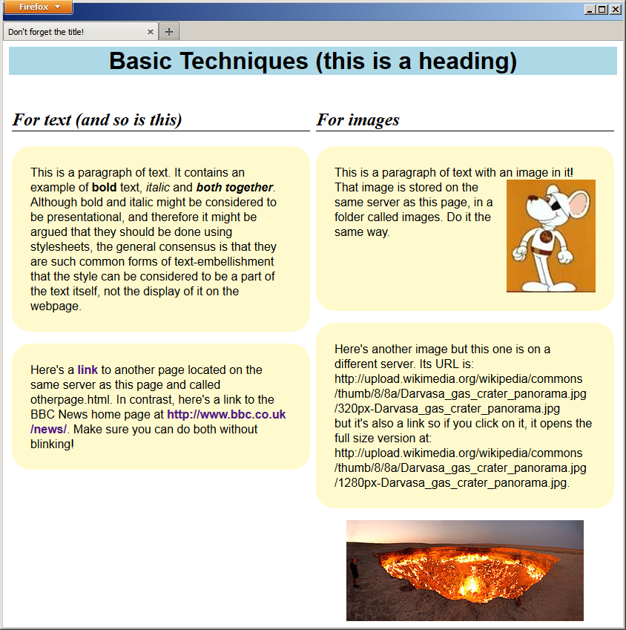

And when the window is made narrower it should look like this:

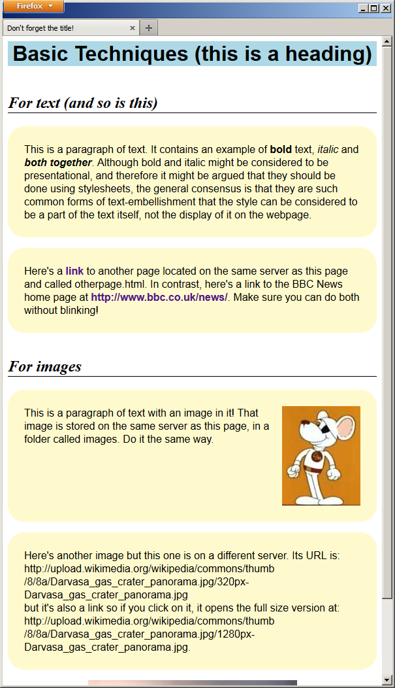

|  |
| --- |
| **EXERCISE 3: BASIC RESPONSIVE DEVELOPMENT** |
| ***Required in your report (basic exercise).*** |
| * The revised HTML code showing the added <div> tags * The contents of the CSS file you used to achieve these results, separated from the CSS rules already there to do the colour etc. * An explanation of each rule in the CSS file and what it does * A clickable link to the completed web page in your Daydream account (this may be the same page as for the previous task). * Reflection on the tasks and all activities involved. |
| ***Extended Tasks*** |
| * Make a page similar to the Beatles page but showing pictures of your top TEN favourite bands (or anything else you like) in a two rows of five, that collapse into five rows of two and then a single vertical column as the window is narrowed. |
| *Additional work: investigate and experiment with any related subject matter that interests you.* |